Hi Sunny –

I’ve done my best to describe the final graphs I’m hoping to achieve from the Jupyter notebook examples. Please let me know if you have any questions. Thank you as always for the help.

Graph 1:

Change y-axis ticks to show the “occurrences_total” field (abbreviated so that 23,000,000 = 23M). Right now, they show as a percent between 0 and 100.

Change y-axis label so that its two lines. Line 1 will read: “Total Est. Viewership” and line 2 will read: “(TV Shows + Movies).

Can the “percent_top_10” field from the dataframe be added as an annotation above each stacked bar?

The image below shows each of the three edits implemented. I added them manually in MS Paint.

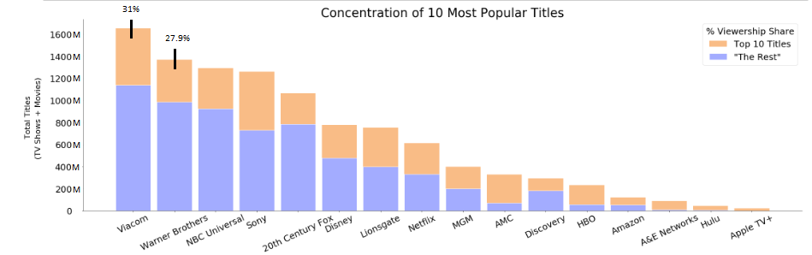

Graph 2

The idea for this graph was taken from this page: <https://matplotlib.org/3.1.0/gallery/pie_and_polar_charts/bar_of_pie.html#sphx-glr-gallery-pie-and-polar-charts-bar-of-pie-py>

What I would essentially like to do is graph a single stacked bar and then have a cut out with lines that will show the top 10 TV shows / movies from a different dataframe. The top 10 is calculated as a percent allowing for the donut to be graphed. I made a mockup in MS Paint to show what I’m hoping to have the final version look approximately like:

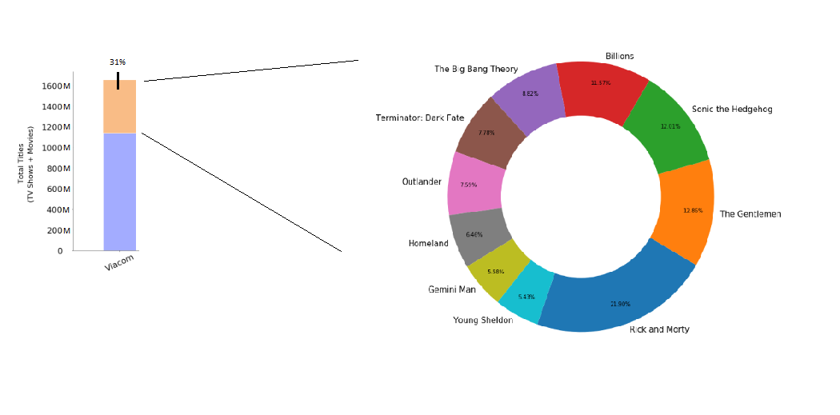

Graph 3

This graph will be the same as graph 2 except that the abbreviated “occurrences” will be shown in the doughnut graph instead of the percent. For example, Rick and Morty would instead read “5.97M” instead of 21.9%.